**Core Java Assignment 7**

**Assignment on Annotation**

**1.**

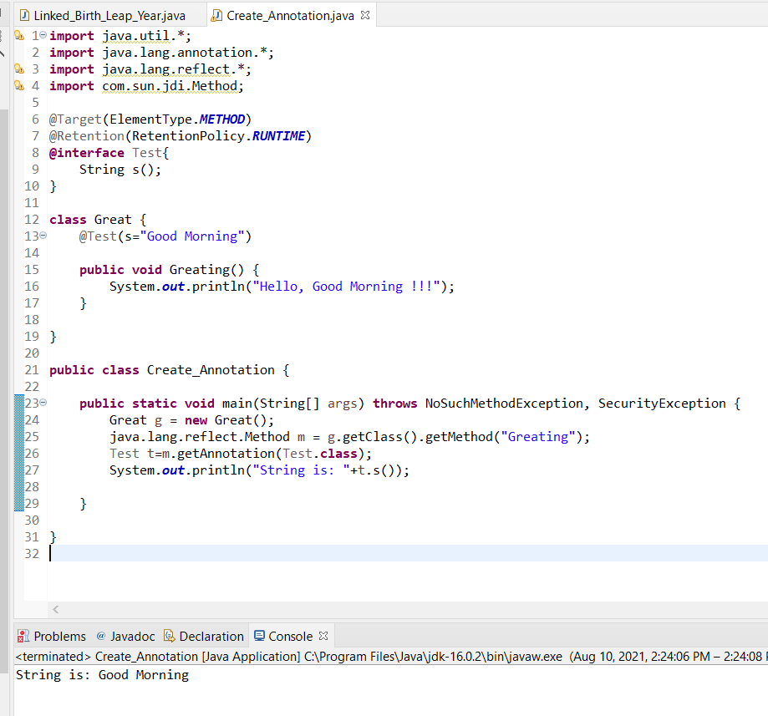

**2.**

**import** java.lang.annotation.ElementType;

**import** java.lang.annotation.Retention;

**import** java.lang.annotation.RetentionPolicy;

**import** java.lang.annotation.Target;

@Retention(RetentionPolicy.***RUNTIME***)

@Target(ElementType.***TYPE***)

**@interface** Info{

**int** Authorid();

String Authorname();

String date();

String time();

**int** version();

String desc();

}

@Info(Authorid=100,Authorname="George r. R. Martin",date="01/08/1997",time="10am",version=1,desc="it is first novel in A Song of Ice Fire, a series of fantasy novels by the american author")

**class** Info1{

String name;

**public** Info1(String name) {

**super**();

**this**.name = name;

}

**public** String getName() {

**return** name;

}

}

**public** **class** Annotation_Info {

**public** **static** **void** main(String[] args) {

Info1 obj=**new** Info1("Game of Thron");

Class c =obj.getClass();

java.lang.annotation.Annotation an=c.getAnnotation(Info.**class**);

Info s=(Info)an;

System.***out***.println("Aurthor ID: "+s.Authorid()+" Author name: "+s.Authorname()+" Date of Publish "+s.date()+" Description: "+s.desc()+" "+s.time()+" Version of Book: "+s.version());

}

}

**Output:** Aurthor ID: 100 Author name: George r. R. Martin Date of Publish 01/08/1997 Description: it is first novel in A Song of Ice Fire, a series of fantasy novels by the american author 10am Version of Book: 1

**3.**

**import** java.lang.annotation.*;

**import** java.lang.reflect.*;

@Retention(RetentionPolicy.***RUNTIME***)

@Target(ElementType.***METHOD***)

**@interface** Execute

{

**int** Sequence();

}

**class** Annotation

{

@Execute(Sequence=2)

**public** **void** method1()

{

System.***out***.println("Method : 1");

}

@Execute(Sequence=1)

**public** **void** method2()

{

System.***out***.println("Method : 2");

}

@Execute(Sequence=3)

**public** **void** method3()

{

System.***out***.println("Method : 3");

}

}

**public** **class** Annotation_Q3 {

**public** **static** **void** main(String[] args) {

Annotation a= **new** Annotation();

Method[] m= a.getClass().getMethods();

**for** (Method method: m)

{

Execute e= method.getAnnotation(Execute.**class**);

**if** (e!=**null**)

{

**try**

{

method.invoke(a);

System.***out***.println(e);

}

**catch**(Exception x)

{

x.printStackTrace();

}

}

}

}

}

**Output:**

